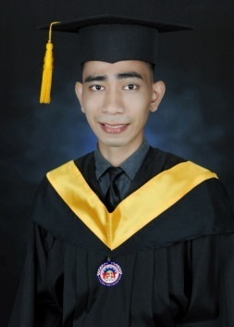**Oliver B. Dela Fuente**

**1920 Obeses St. Pandacan, Manila**

**maebear143@gmail.com**

**09637710968**

**Website Portfolio : https://devolibear.netlify.app**

**CAREER OBJECTIVES**

**I am an easy going person that works well with everyone seeking for a position which will provide me with the opportunity to develop skills in many aspects in the field of computer industry.**

**PERSONAL DETAILS**

**Citizenship : Filipino**

**Height : 5’9, Weight : 60 kg**

**Hobbies : Coding programming languages, Craving coffee, Watching anime episodes**

**Languages : Filipino, English**

**EDUCATIONAL BACKGROUND**

**Bagong Barangay Elementary School**

**Year Graduated : 2000 - 2006**

**St. Charles Educational Institution**

**Year Graduated : 2008 - 2012**

**ICCT COLLEGES FOUNDATION INC.**

**Year Graduated : August 2017 - April 2022**

* **Bachelor of Science in Information Technology**

**SKILLS**

**Computer Technical Skills :**

* **Security - Maintaining software up to date with the newest security patches, installing anti-virus and other necessary software to improve the security performances.**
* **Software - Installing software and application to user standards.**
* **Hardware - Installing and configuring the peripherals, components and drivers, computer assembling and maintenance.**
* **Back-up and Restore - Backup Management, Reporting and Recovery.**
* **Reformatting – Performs reformat solutions both Desktop and Laptop when needed.**

**Graphic Designing Skills :**

* **Adobe Photoshop - Photo editing of pictures, removing of background, changing background, image resizing.**
* **Canva - Creating custom templates, editing pictures, video editing.**

**Programming Skills :**

* **PHP MySQL - creating database with PHP Data Object connection and has the functionality of Create, Read, Update, Delete and Object Oriented Programming based.**
* **Bootstrap Framework - A combination of HTML and CSS based design templates for typography, forms, buttons, tables, navigation, modals, images and many other, as well as optional JavaScript plugins.**
* **HTML/CSS/JavaScript - I can create a full static responsive design website from scratch without any framework use and compatible for both Android/Desktop.**

**WORK EXPERIENCE**

**Super Clean Service Corp.**

**Housekeeping Attendant - 2014 to 2019**

**Ali Mall - Araneta City - under agency, Super Clean Services Corp.**

**Data Entry : 2020 - 2021**

**Safeguard DNA Diagnostic Inc.**

**Data Encoder : February 22, 2022 to present.**

**REFERENCES**

**Maria Paola Sia**

**+639362910600**

**Registered Nurse - Safeguard DNA Diagnostic Inc.**

**Mark Rigo Palluto**

**09171407213**

**Human Resources - Safeguard DNA Diagnostic Inc.**

**Jeron Delos Santos**

**09105803602**

**Sanitation Officer - Araneta City Inc.**

**Training Certifications**

